Intro and menu are in English
Ibiri muri iyi module
Remove the emojis
Ibiri mu isomo
Mixed numbering and emoji. It needs to be numbering.
There should be only one line per item as it has now two lines that indicate the same.
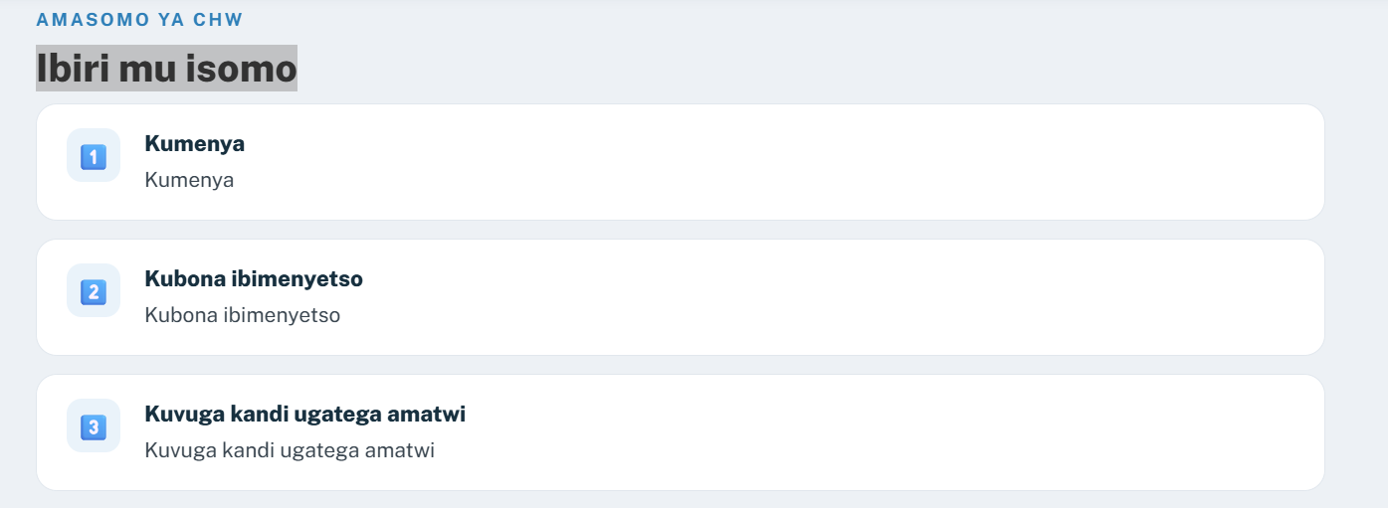
Icyo wakora
This slide is repeated. Please keep it only in it’s second location right after initiation session 1).
Aho igifu giherereye
Plus signs to expand are incorrectly placed. 1. Should be in the esophagus, 2. should be in the gastric chamber, and 3. Should be in the intestine.
Uko kanseri y'igifu itangira
Images did not migrate. Make sure each image migrates to it’s respective item as there are 3 different.
Kanseri y'igifu mu Rwanda
Graph did not migrate.
Ibyongera ibyago
The note from the bottom of the slide is missing.
Ibimenyetso byo gukurikirana
Should be bulleted content inside the box and not running text
Urugendo rwo kwivuza mu Rwanda
The note from the bottom of the slide is missing.
Uko icyateye iyi ndwara cyamenyekana
The note from the bottom of the slide is missing.
Gusobanurira umuryango ibizamini
Should be bulleted content inside the box and not running text
Section 1
This view in the platform got some legend in the image that was not existing on the ppt. Should be removed as it is in English
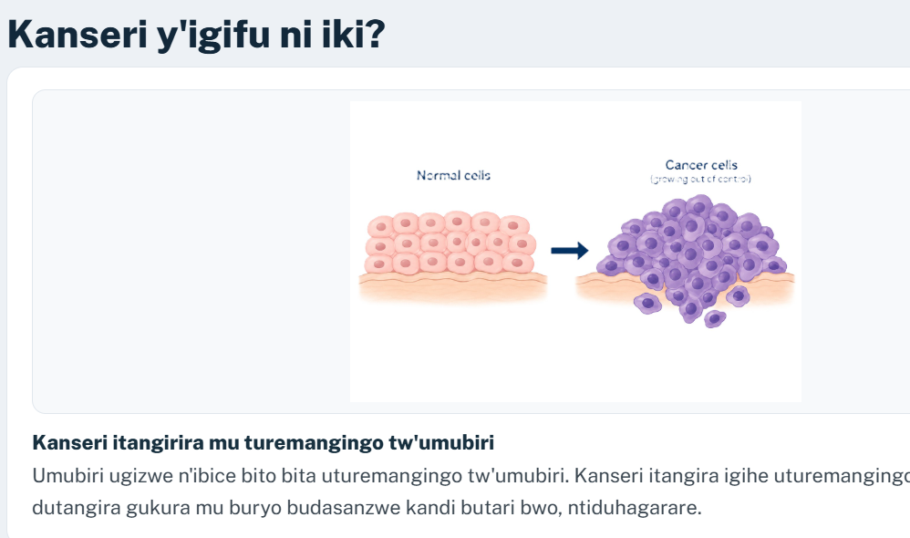

On the slide for the last square there is only the image of the tree as here:
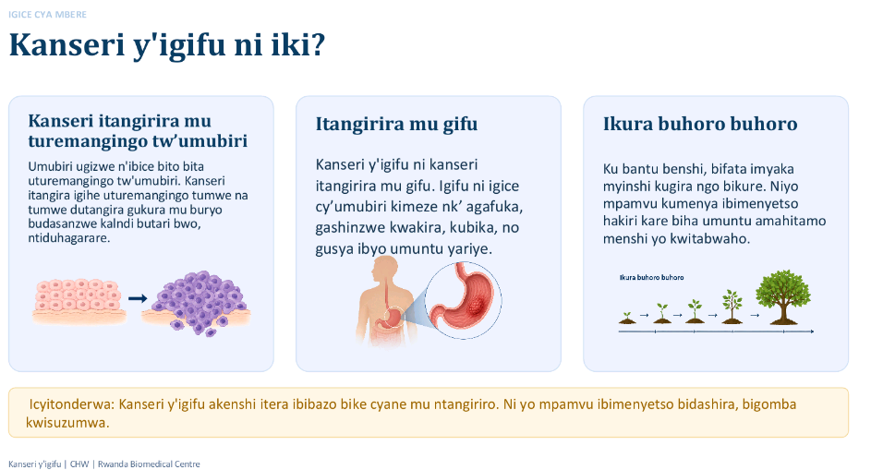

In the platform I see that it was added more so please double check:

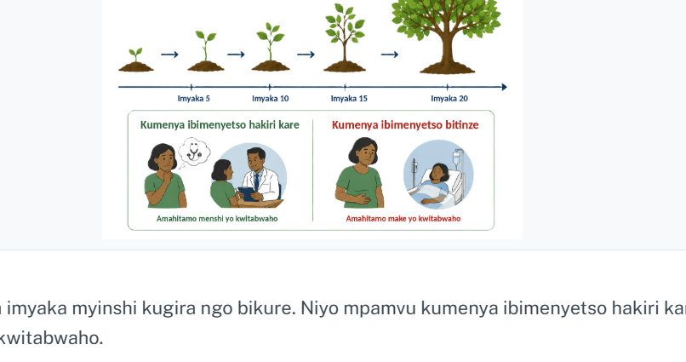

This slide lost the infographics that were in the ppt. It should not be just with the text.
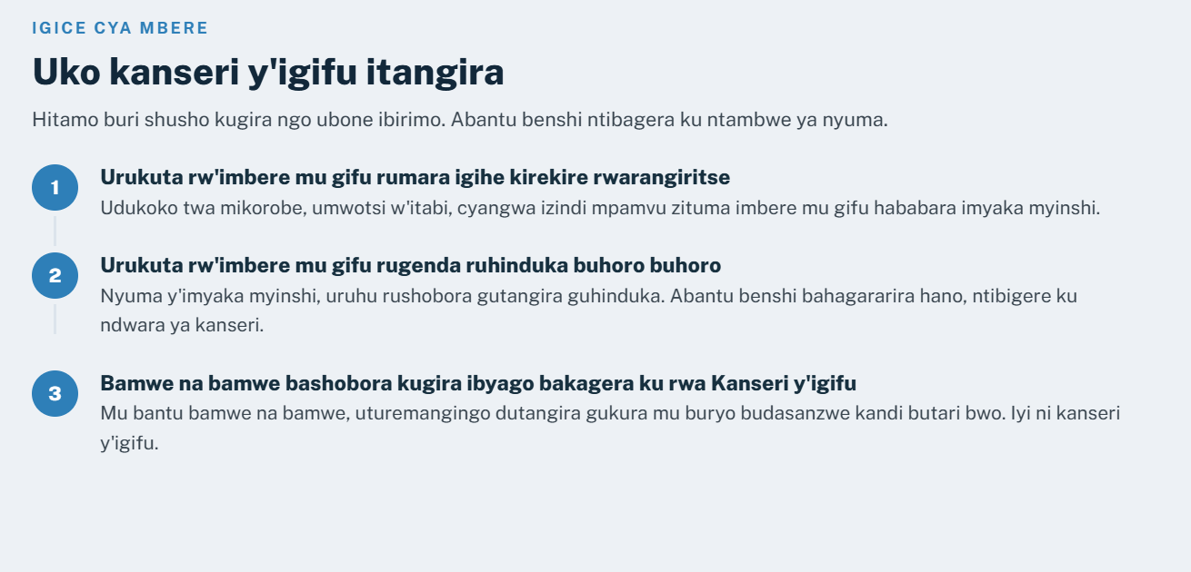
This is how it looks in the ppt:
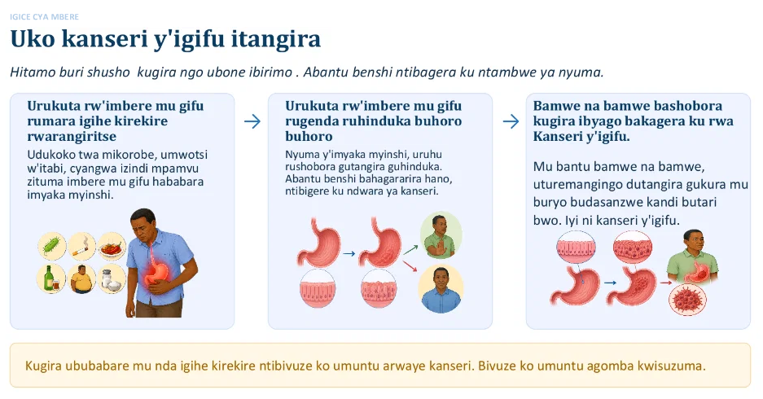

This next screen is also not correct as the image of the pills that is showing on the second box should be on the third one
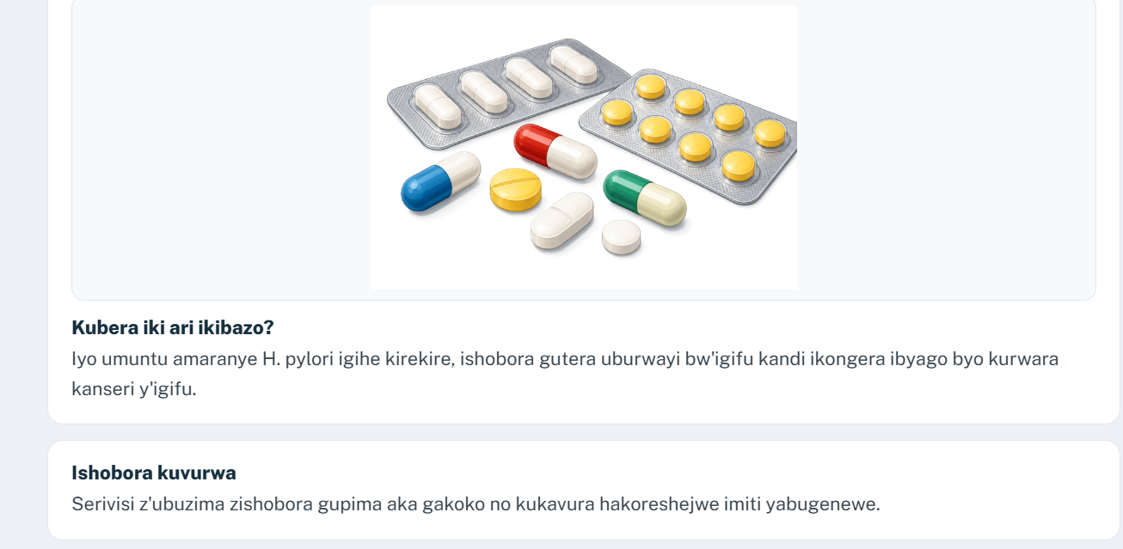
This is how it looks in the ppt:
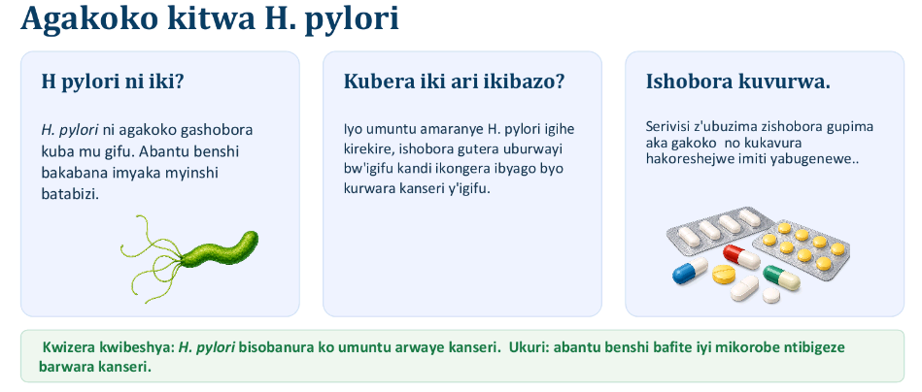

On this page:
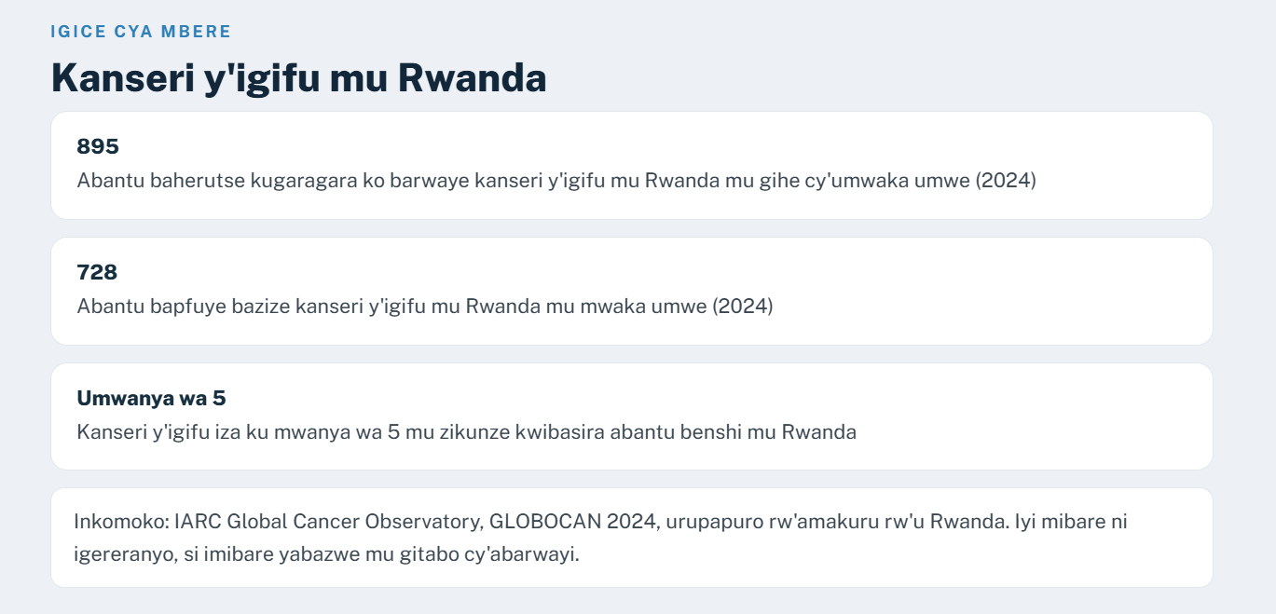the last rectangule is just the reference. Could be in smaller font: there is not the need to have it so big. Also could be better to have the style closer as it was in the ppt with different colors in the boxes. The bar graphic has disappeared and should be there as well.
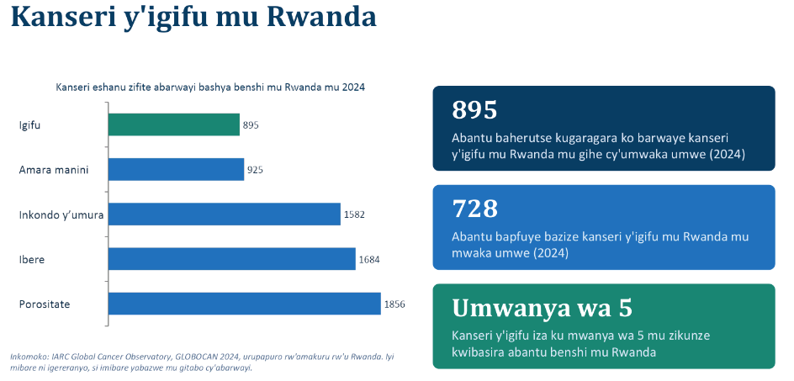

Section 2
This slide should have the info close to the image with bullets as it is in the ppt and not as a legend
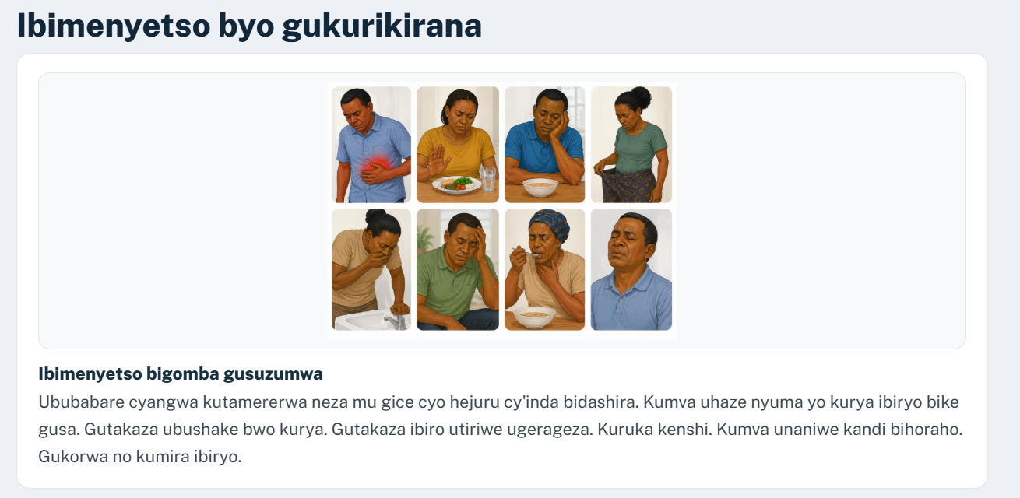

Section 3
In this screen on the platform there is not the last yellow box from the ppt and it should be included
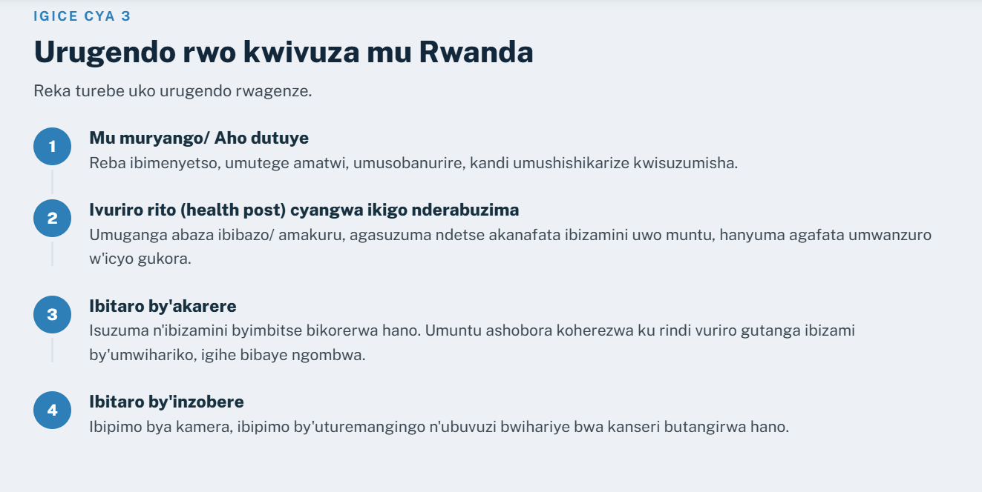

SECTION 4
This screen has the image and the info as if it was a legend. It would have a better readability if this would go back to bullets as it was in the ppt.

